**Recommended Revision Guides Year 3**

Reading: Comprehension

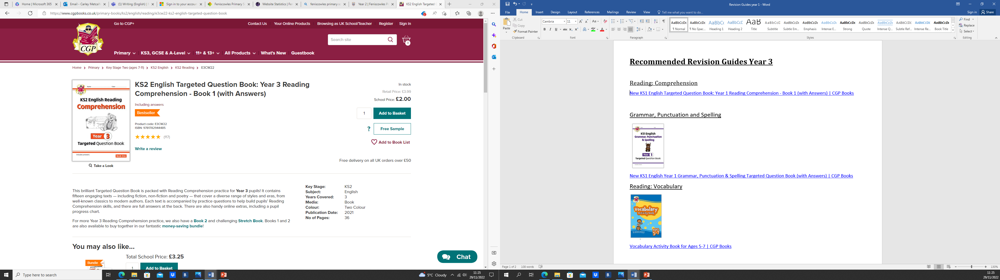

[KS2 English Targeted Question Book: Year 3 Reading Comprehension - Book 1 (with Answers) | CGP Books](https://www.cgpbooks.co.uk/primary-books/ks2/english/reading/e3cw22-ks2-english-targeted-question-book)

Grammar, Punctuation and Spelling

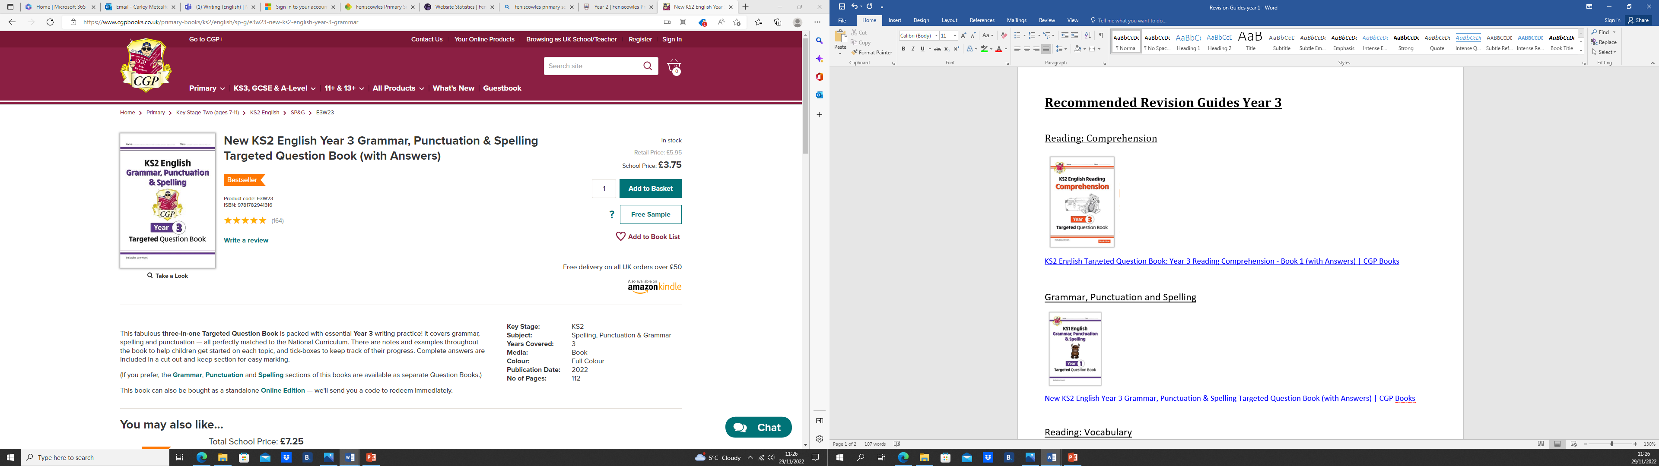

[New KS2 English Year 3 Grammar, Punctuation & Spelling Targeted Question Book (with Answers) | CGP Books](https://www.cgpbooks.co.uk/primary-books/ks2/english/sp-g/e3w23-new-ks2-english-year-3-grammar)

Reading: Vocabulary

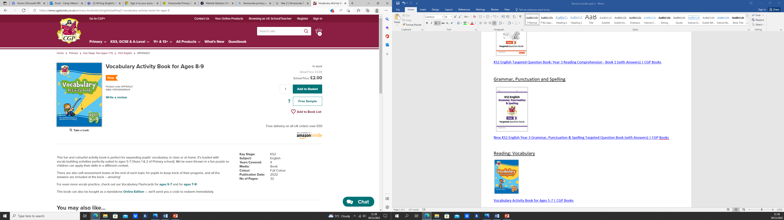

[Vocabulary Activity Book for Ages 8-9 | CGP Books](https://www.cgpbooks.co.uk/primary-books/ks2/english/epf4vq21-vocabulary-activity-book-for-ages-8)

Maths: Mixed topics

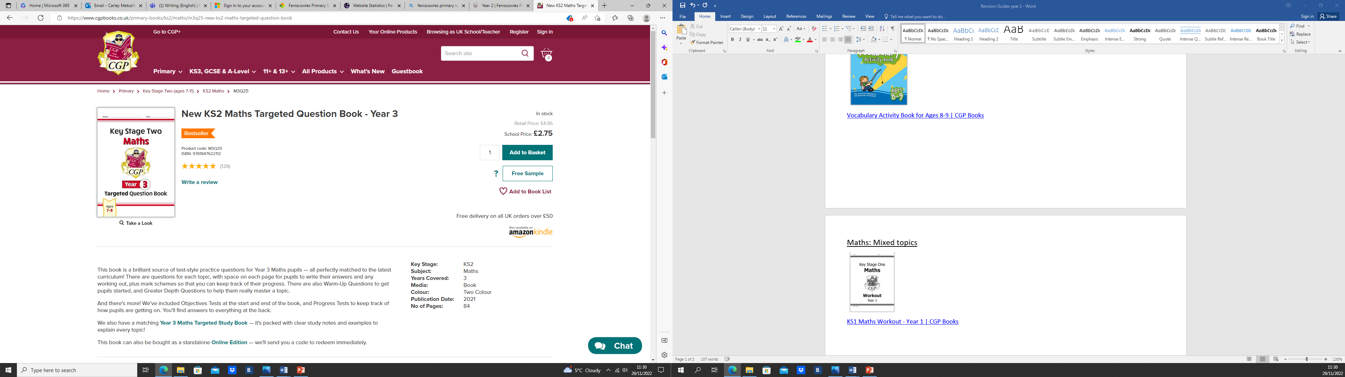

[New KS2 Maths Targeted Question Book - Year 3 | CGP Books](https://www.cgpbooks.co.uk/primary-books/ks2/maths/m3q25-new-ks2-maths-targeted-question-book)

**Maths: Fractions**

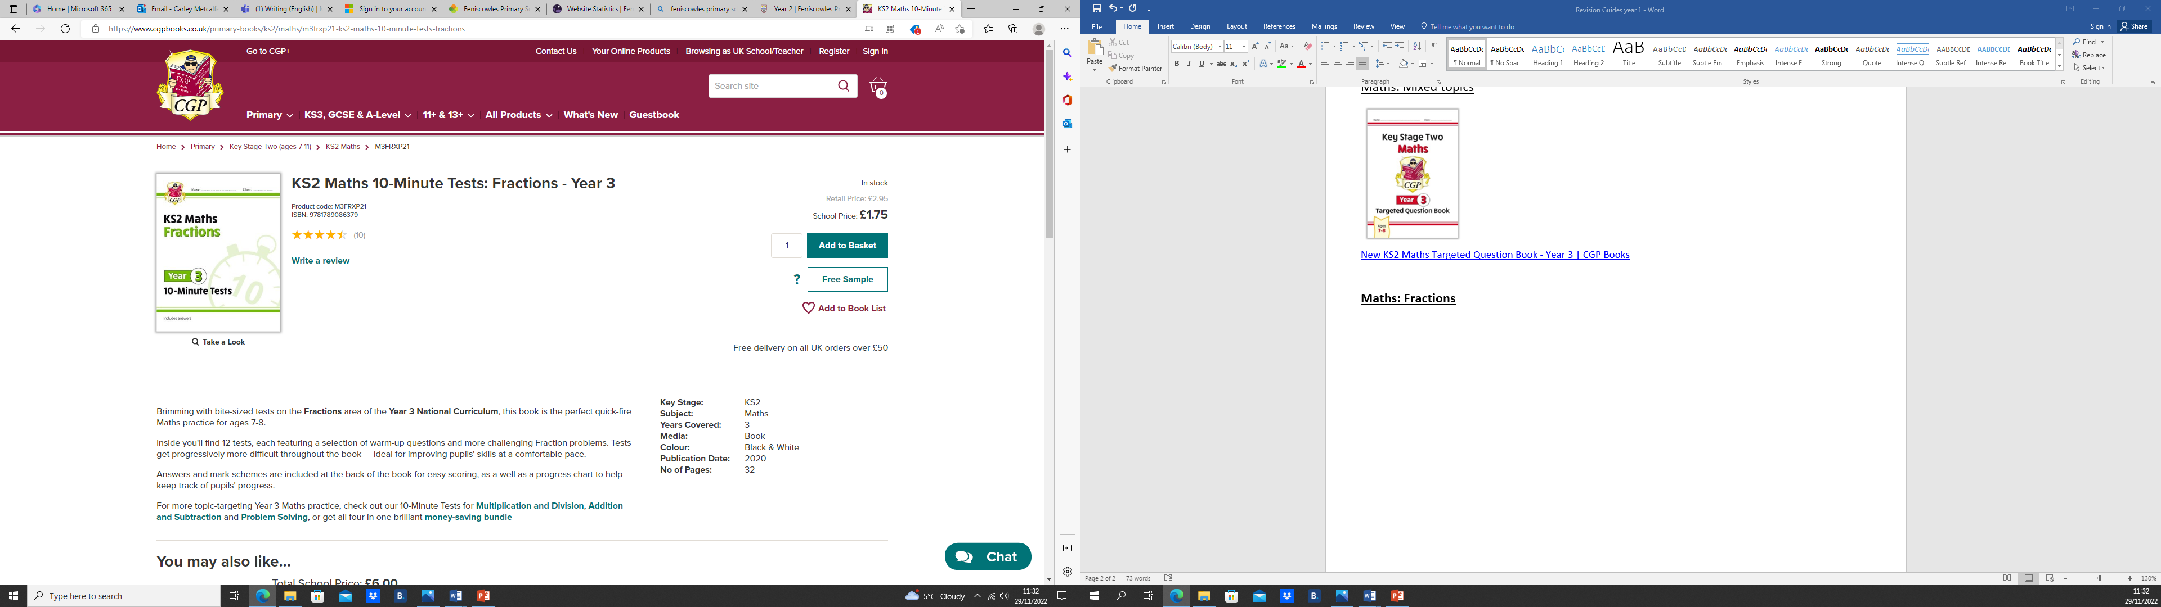

[KS2 Maths 10-Minute Tests: Fractions - Year 3 | CGP Books](https://www.cgpbooks.co.uk/primary-books/ks2/maths/m3frxp21-ks2-maths-10-minute-tests-fractions)

Or

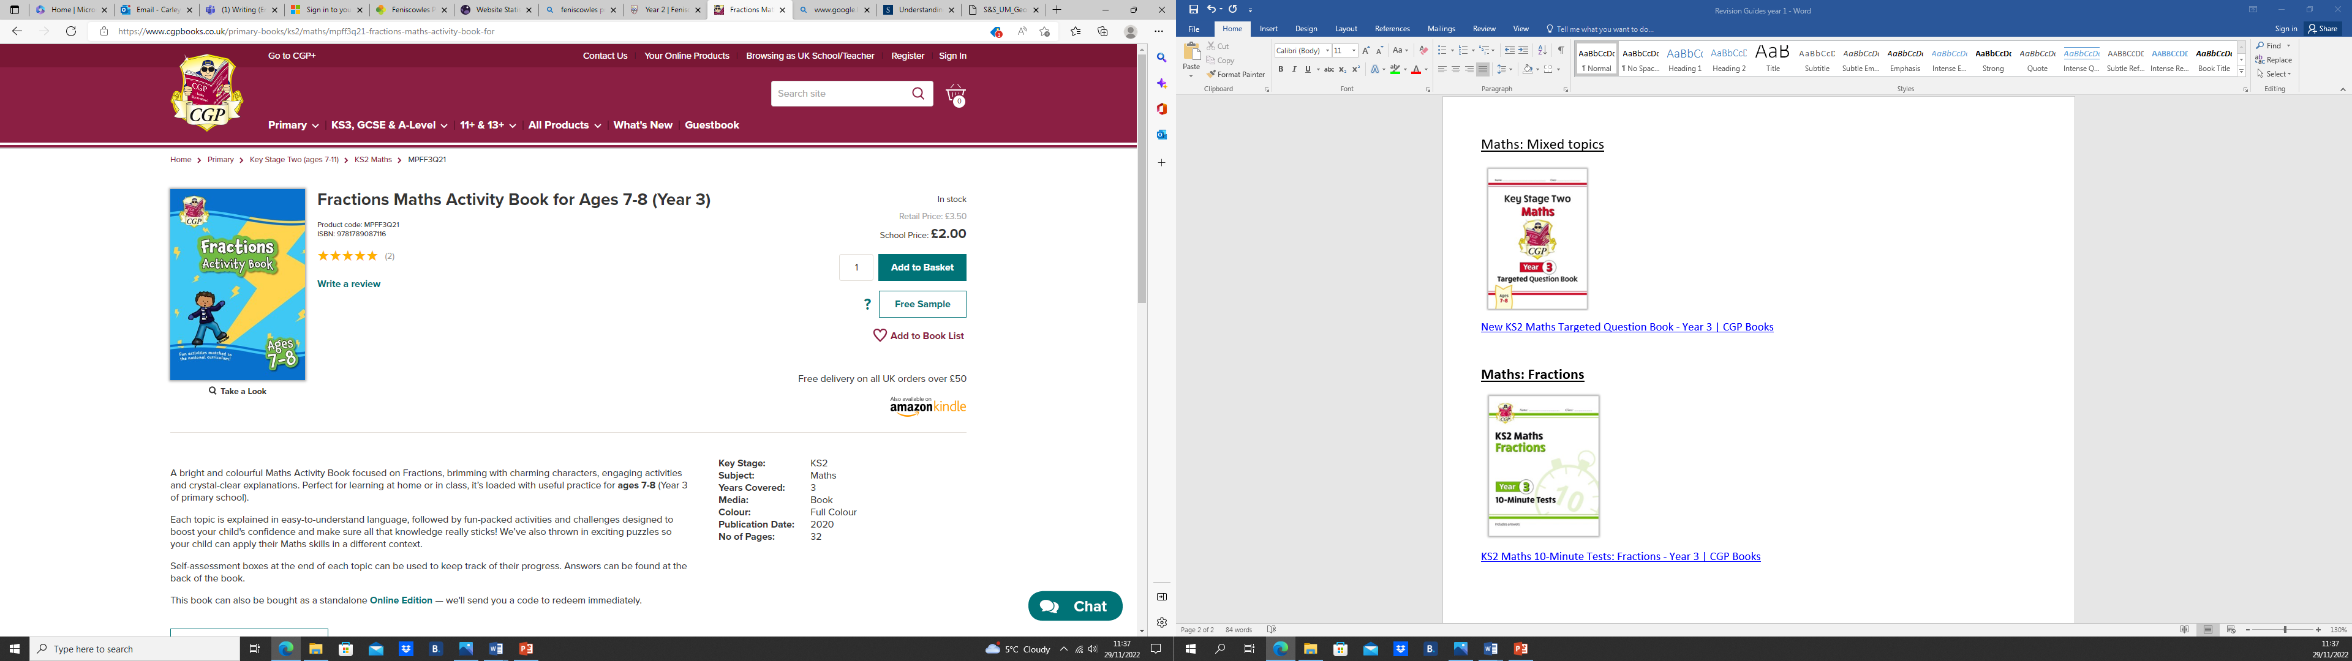

[Fractions Maths Activity Book for Ages 7-8 (Year 3) | CGP Books](https://www.cgpbooks.co.uk/primary-books/ks2/maths/mpff3q21-fractions-maths-activity-book-for)