**Recommended Revision Guides Year 1**

Reading: Comprehension

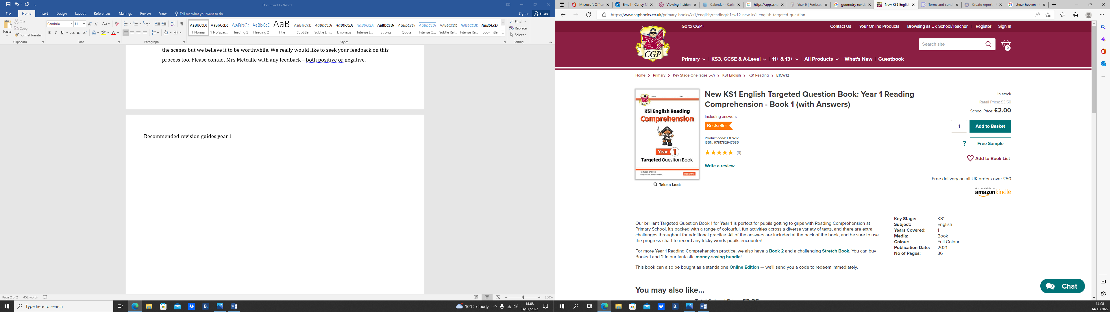

[New KS1 English Targeted Question Book: Year 1 Reading Comprehension - Book 1 (with Answers) | CGP Books](https://www.cgpbooks.co.uk/primary-books/ks1/english/reading/e1cw12-new-ks1-english-targeted-question)

Grammar, Punctuation and Spelling

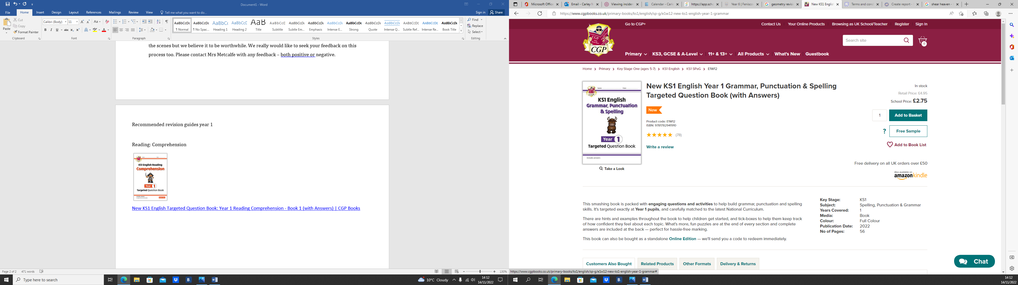

[New KS1 English Year 1 Grammar, Punctuation & Spelling Targeted Question Book (with Answers) | CGP Books](https://www.cgpbooks.co.uk/primary-books/ks1/english/sp-g/e1w12-new-ks1-english-year-1-grammar)

Reading: Vocabulary

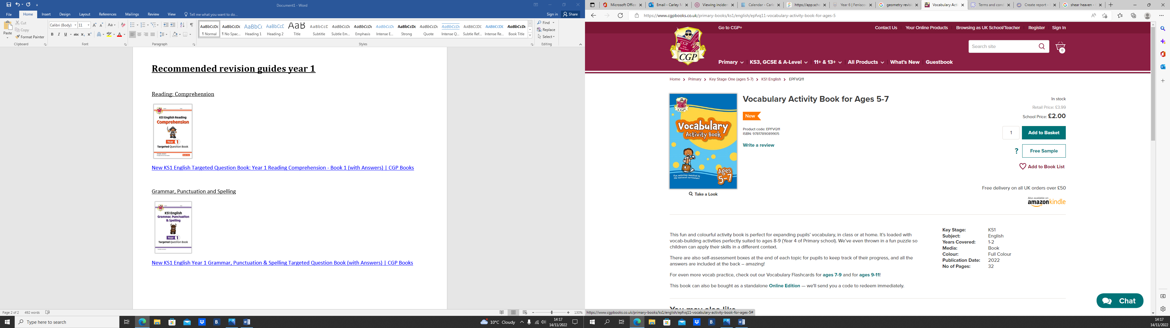

[Vocabulary Activity Book for Ages 5-7 | CGP Books](https://www.cgpbooks.co.uk/primary-books/ks1/english/epfvq11-vocabulary-activity-book-for-ages-5)

Maths: Mixed topics

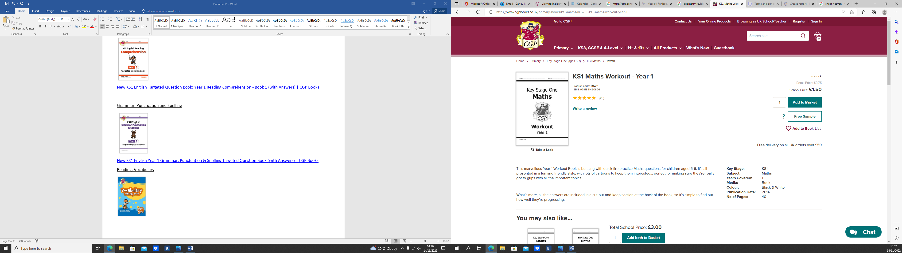

[KS1 Maths Workout - Year 1 | CGP Books](https://www.cgpbooks.co.uk/primary-books/ks1/maths/m1w11-ks1-maths-workout-year-1)

**Maths: Support with Number**

Start with book 1 or 2 in the autumn term. Select book 3 or 4 in the Spring term and book 5 in the summer term: grap.

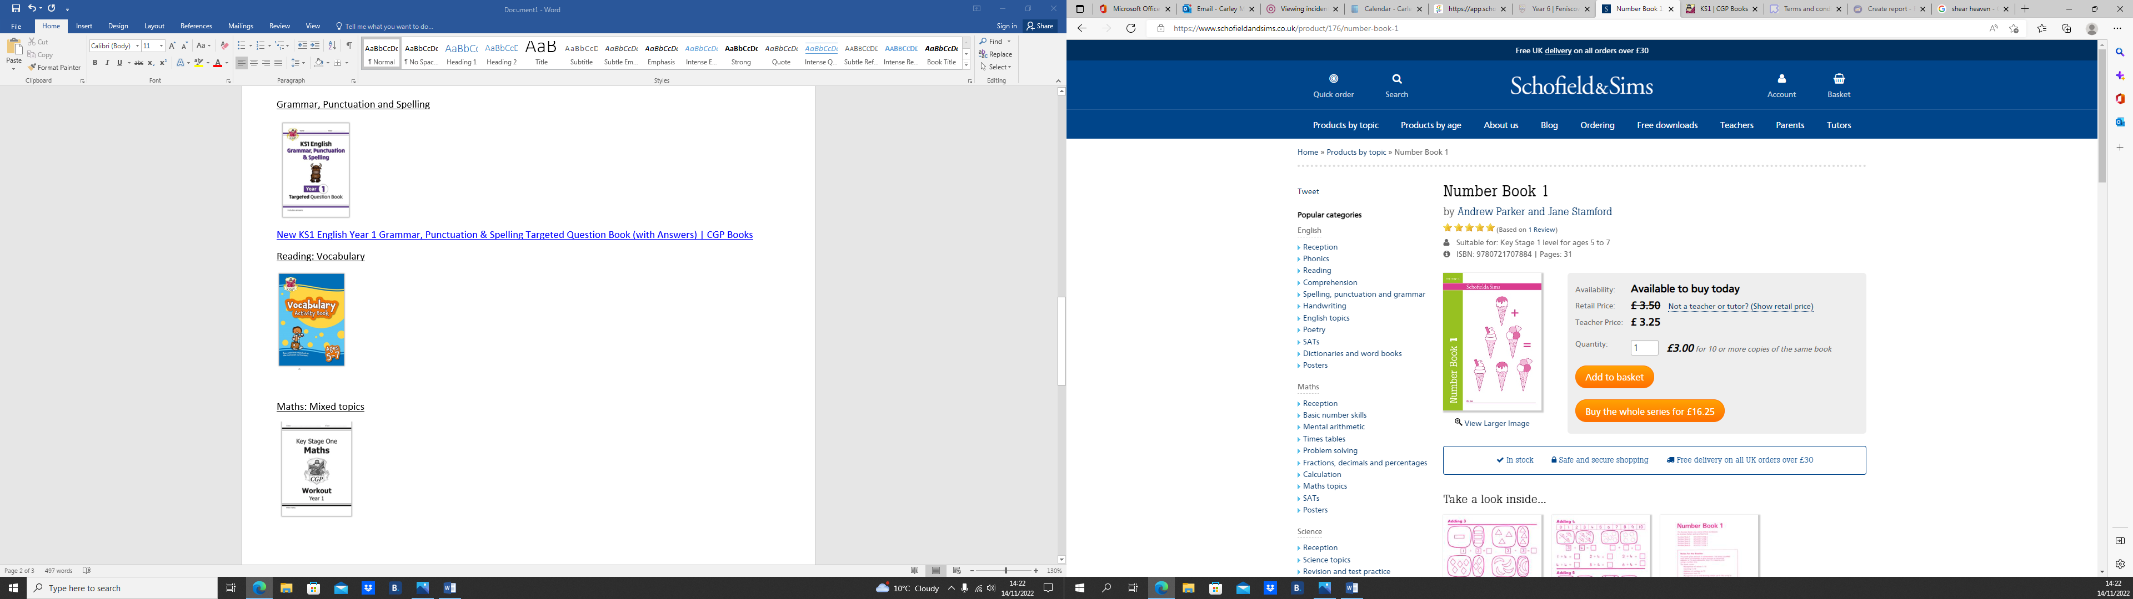

[Number Book 1: Workbooks at Schofield and Sims.](https://www.schofieldandsims.co.uk/product/176/number-book-1)