**Recommended Revision Guides Year 5**

Reading: Comprehension

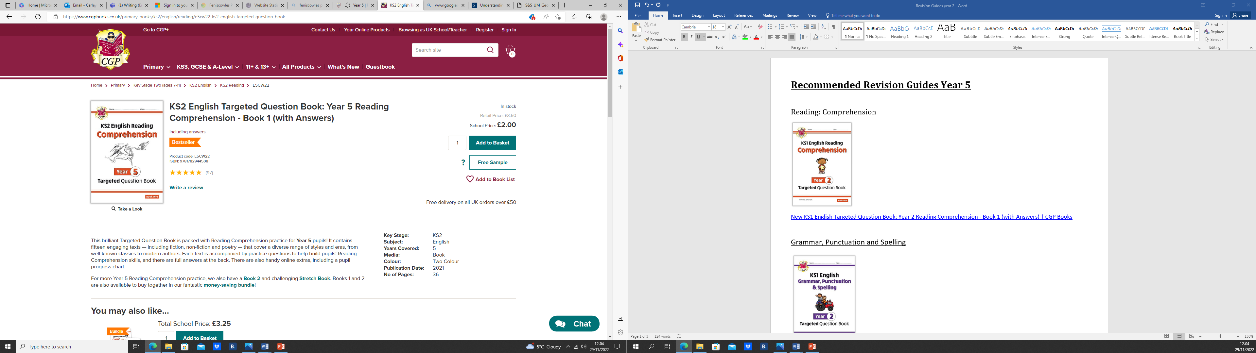

[KS2 English Targeted Question Book: Year 5 Reading Comprehension - Book 1 (with Answers) | CGP Books](https://www.cgpbooks.co.uk/primary-books/ks2/english/reading/e5cw22-ks2-english-targeted-question-book)

Grammar, Punctuation and Spelling

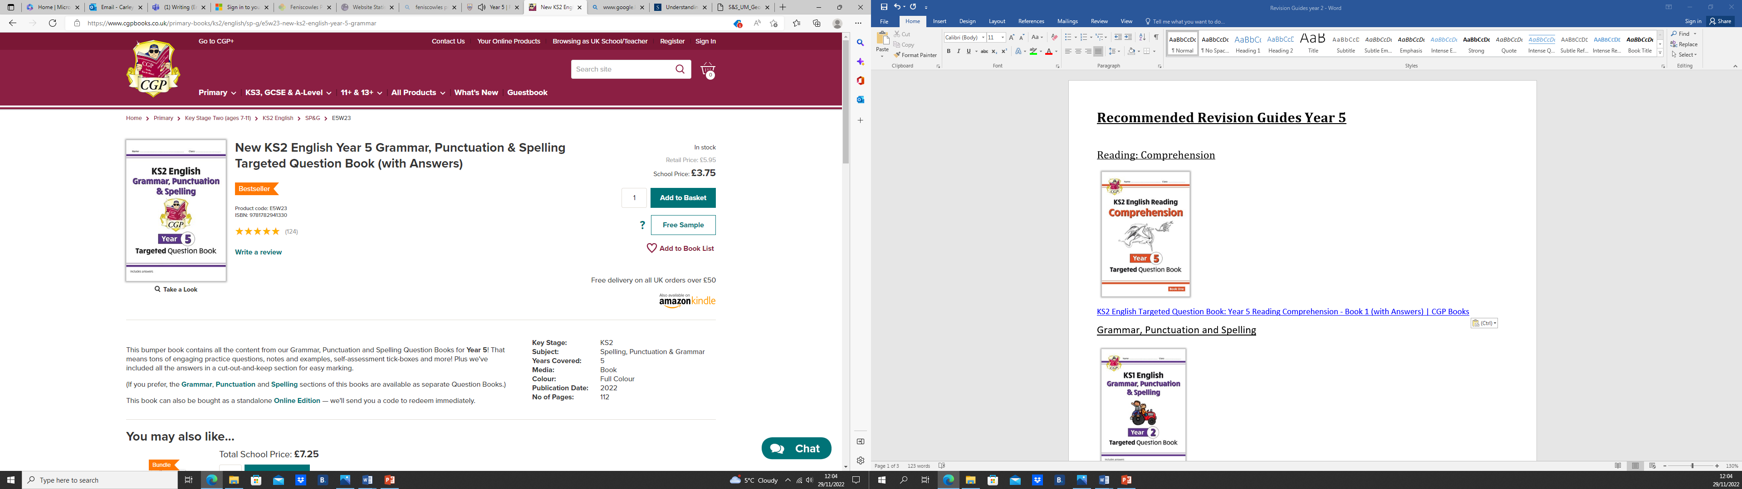

[New KS2 English Year 5 Grammar, Punctuation & Spelling Targeted Question Book (with Answers) | CGP Books](https://www.cgpbooks.co.uk/primary-books/ks2/english/sp-g/e5w23-new-ks2-english-year-5-grammar)

or

Reading: Spelling and Vocabulary

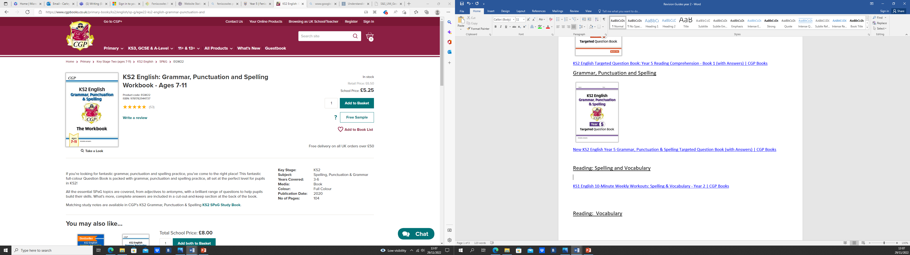

[KS2 English: Grammar, Punctuation and Spelling Workbook - Ages 7-11 | CGP Books](https://www.cgpbooks.co.uk/primary-books/ks2/english/sp-g/egw22-ks2-english-grammar-punctuation-and)

Reading: Punctuation

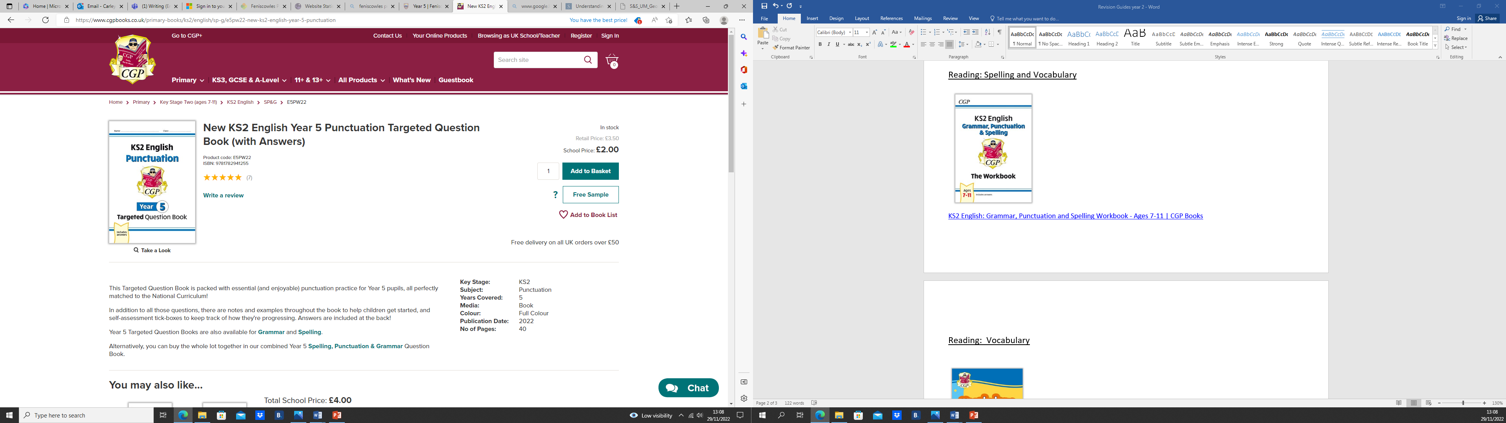

[New KS2 English Year 5 Punctuation Targeted Question Book (with Answers) | CGP Books](https://www.cgpbooks.co.uk/primary-books/ks2/english/sp-g/e5pw22-new-ks2-english-year-5-punctuation)

Reading: Vocabulary

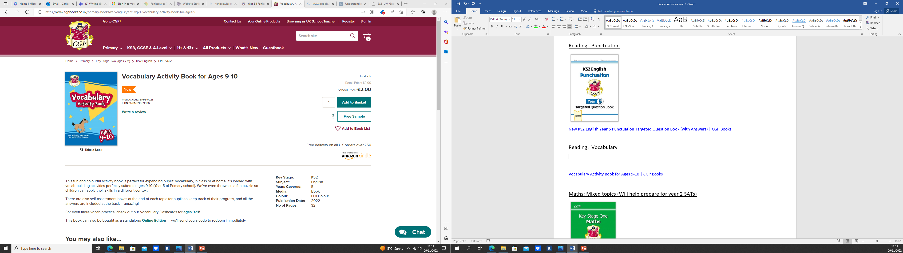

[Vocabulary Activity Book for Ages 9-10 | CGP Books](https://www.cgpbooks.co.uk/primary-books/ks2/english/epf5vq21-vocabulary-activity-book-for-ages-9)

Maths: Mixed topics

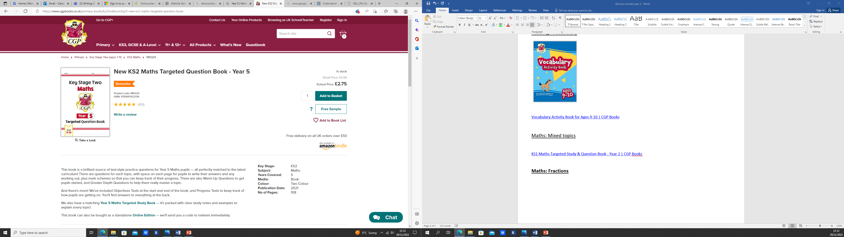

[New KS2 Maths Targeted Question Book - Year 5 | CGP Books](https://www.cgpbooks.co.uk/primary-books/ks2/maths/m5q25-new-ks2-maths-targeted-question-book)

**Maths: Fractions**

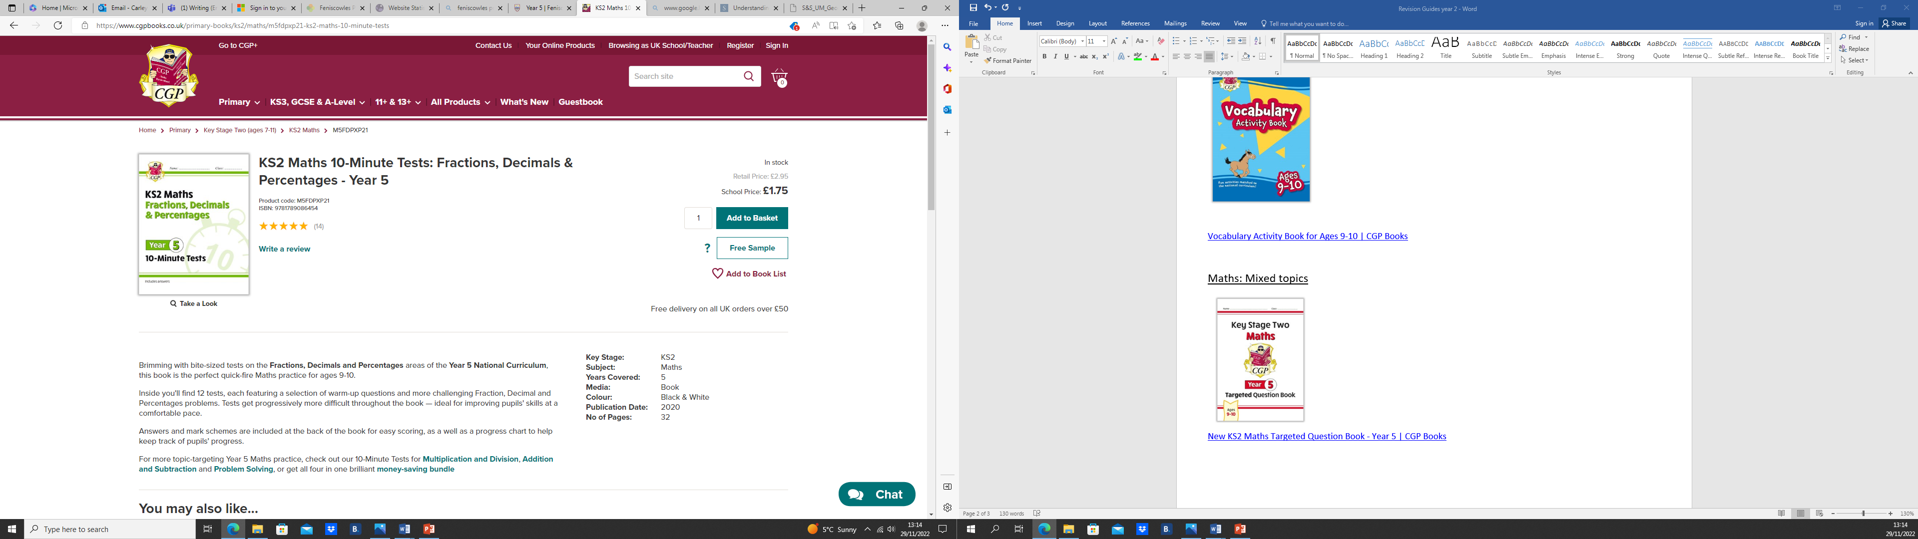

[KS2 Maths 10-Minute Tests: Fractions, Decimals & Percentages - Year 5 | CGP Books](https://www.cgpbooks.co.uk/primary-books/ks2/maths/m5fdpxp21-ks2-maths-10-minute-tests)

**Maths: Geometry, statistics and measures**

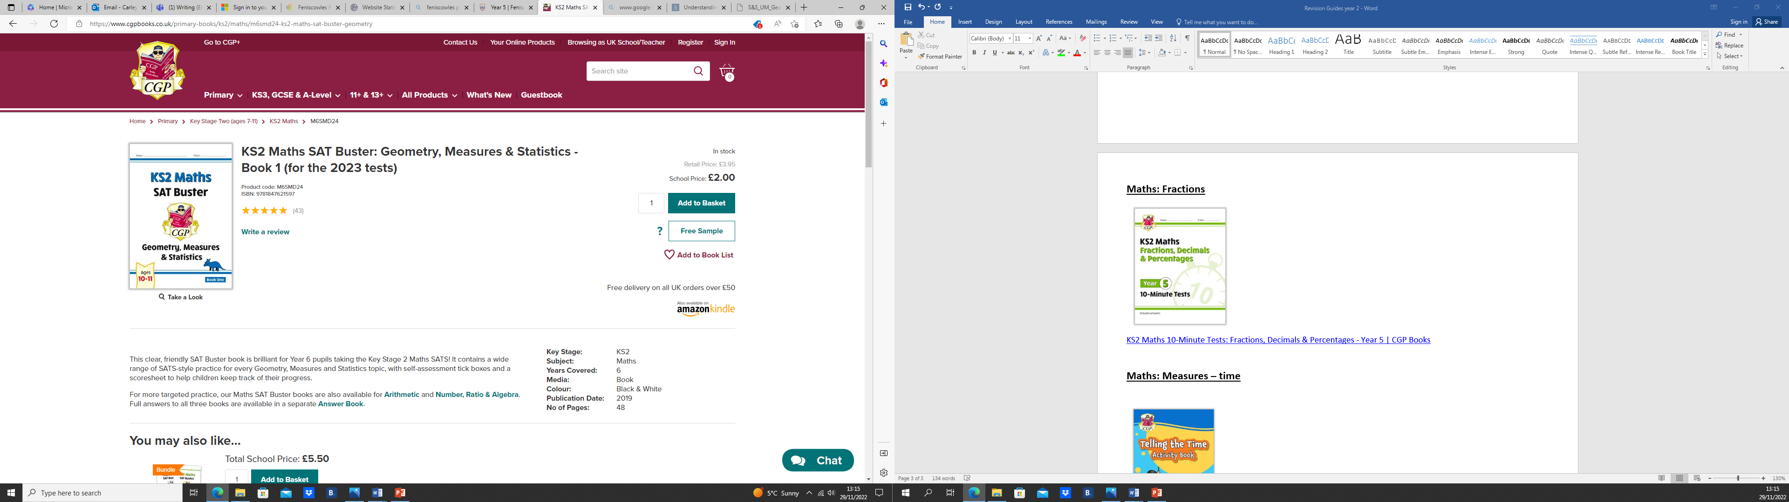

[KS2 Maths SAT Buster: Geometry, Measures & Statistics - Book 1 (for the 2023 tests) | CGP Books](https://www.cgpbooks.co.uk/primary-books/ks2/maths/m6smd24-ks2-maths-sat-buster-geometry)