**Recommended Revision Guides Year 6**

Reading: Comprehension

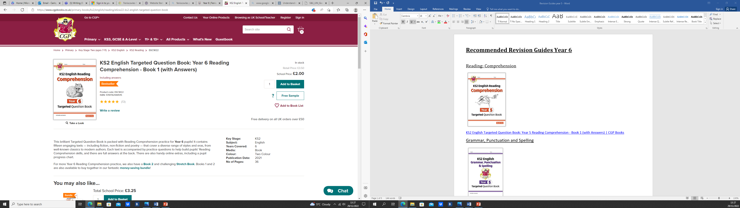

[KS2 English Targeted Question Book: Year 6 Reading Comprehension - Book 1 (with Answers) | CGP Books](https://www.cgpbooks.co.uk/primary-books/ks2/english/reading/e6cw22-ks2-english-targeted-question-book)

English: Grammar, Punctuation and Spelling

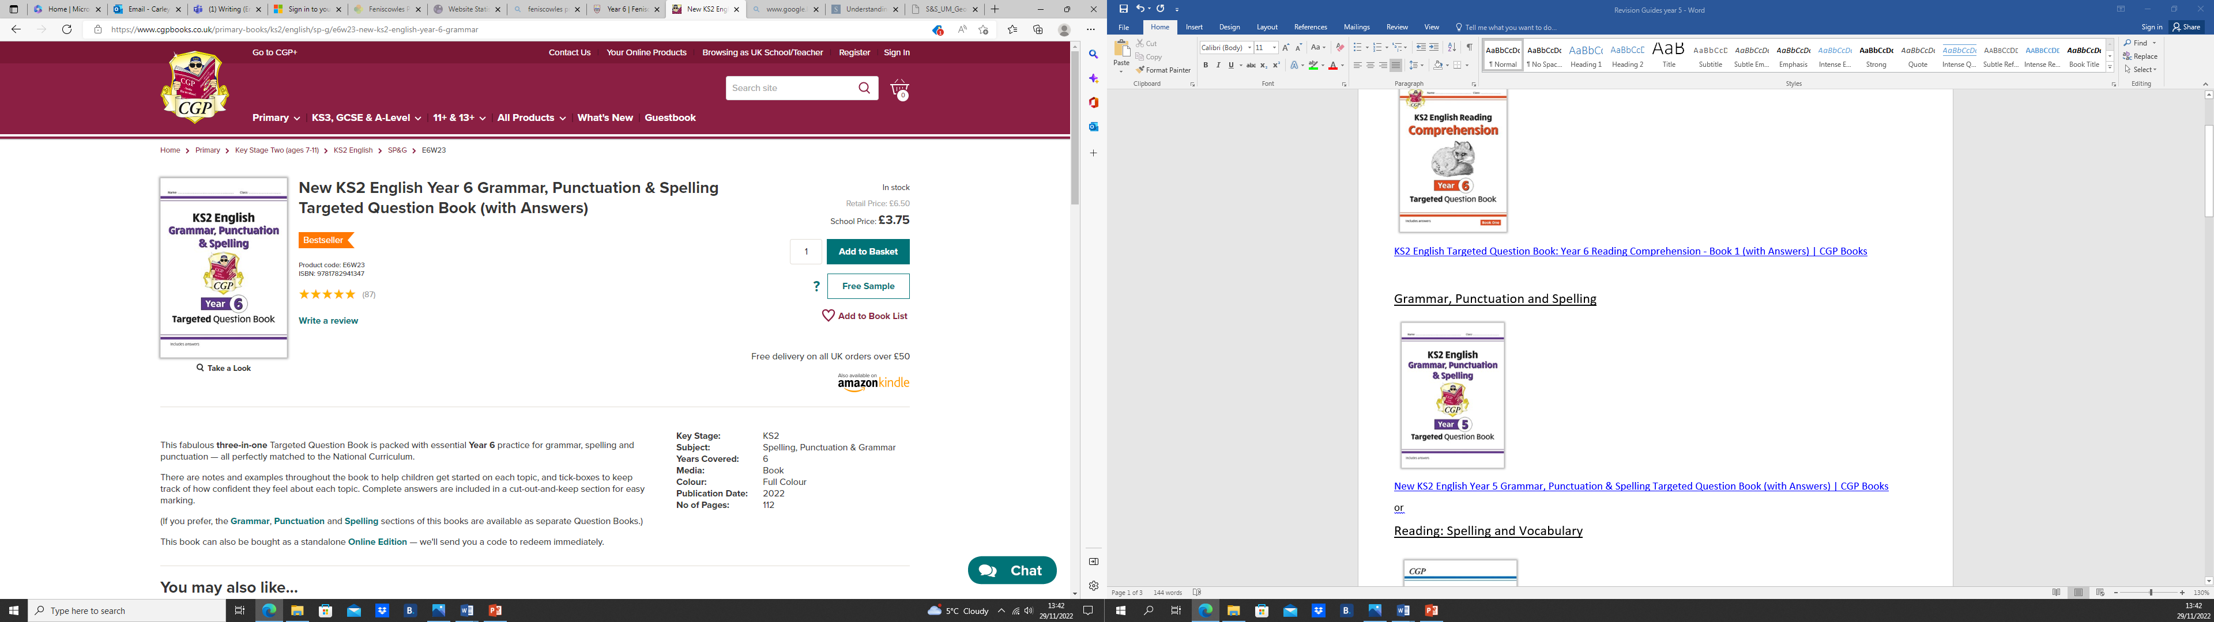

[New KS2 English Year 6 Grammar, Punctuation & Spelling Targeted Question Book (with Answers) | CGP Books](https://www.cgpbooks.co.uk/primary-books/ks2/english/sp-g/e6w23-new-ks2-english-year-6-grammar)

English Spelling

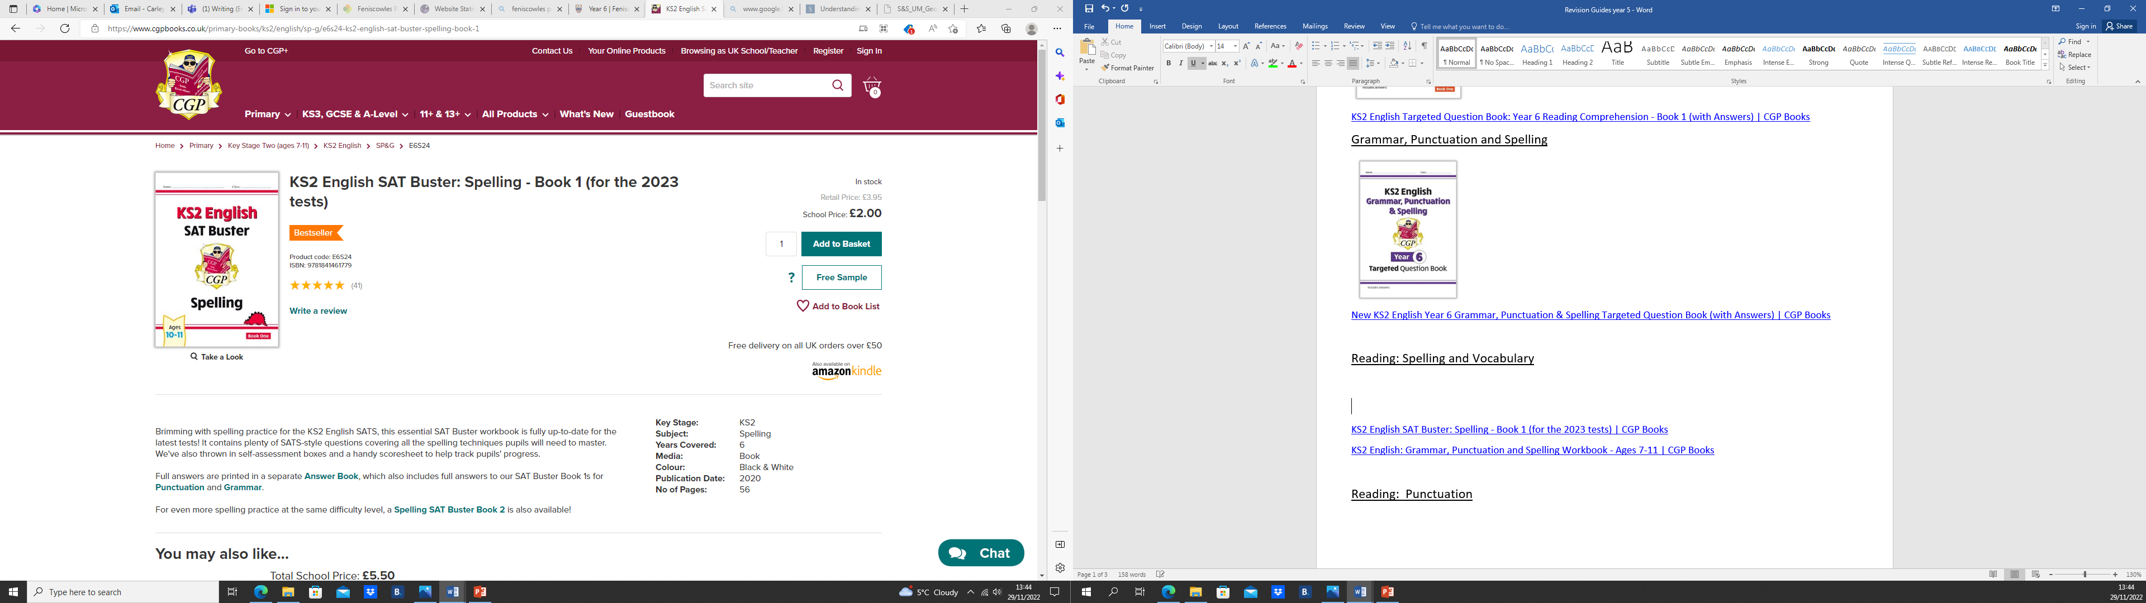

[KS2 English SAT Buster: Spelling - Book 1 (for the 2023 tests) | CGP Books](https://www.cgpbooks.co.uk/primary-books/ks2/english/sp-g/e6s24-ks2-english-sat-buster-spelling-book-1)

Maths: Number, Algebra and Ratio

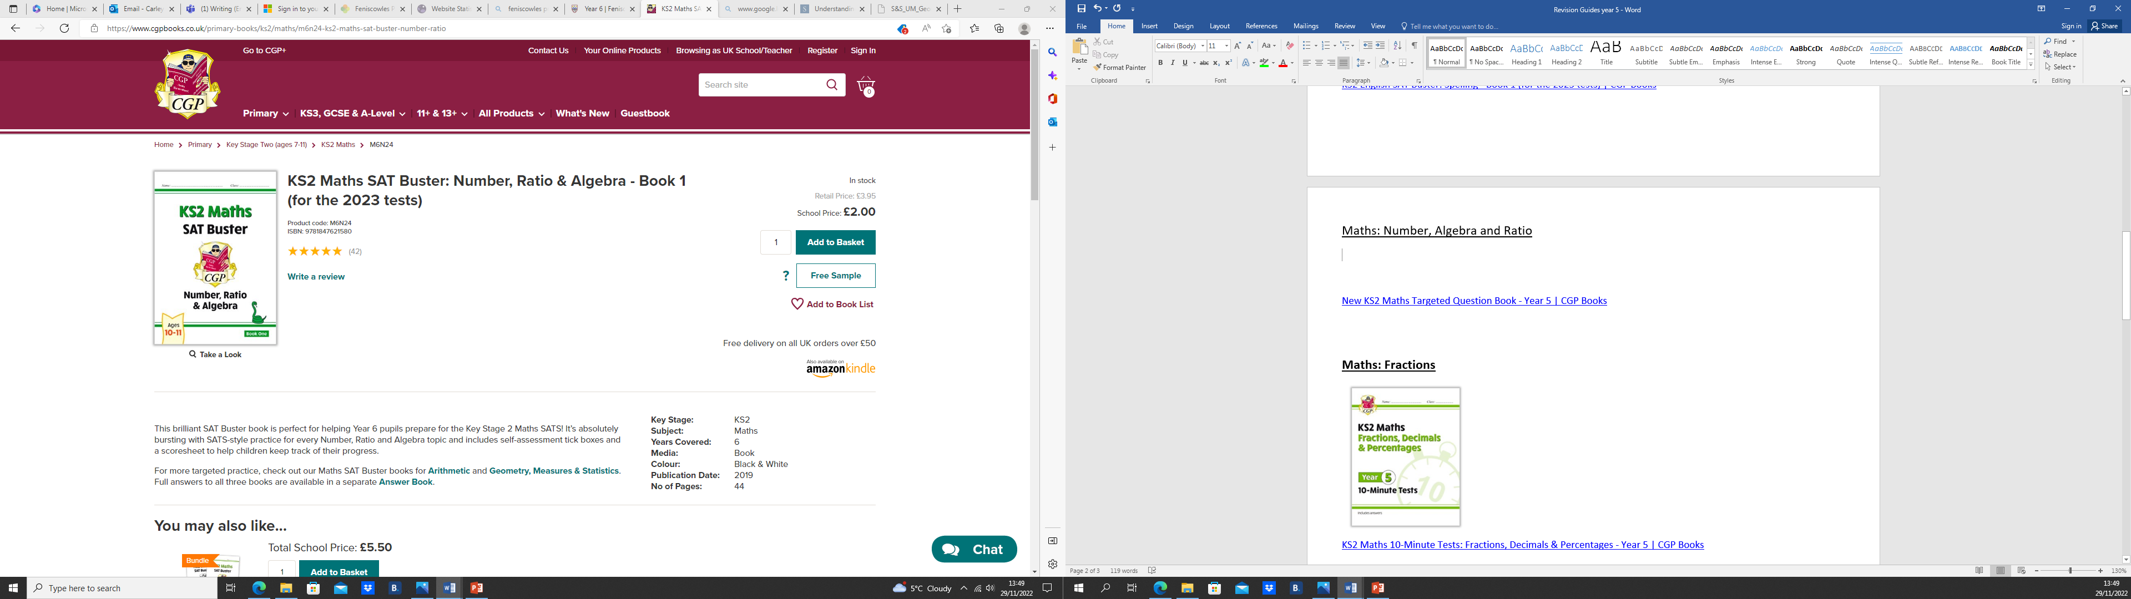

[KS2 Maths SAT Buster: Number, Ratio & Algebra - Book 1 (for the 2023 tests) | CGP Books](https://www.cgpbooks.co.uk/primary-books/ks2/maths/m6n24-ks2-maths-sat-buster-number-ratio)

Maths: Geometry, Measures and Statistics

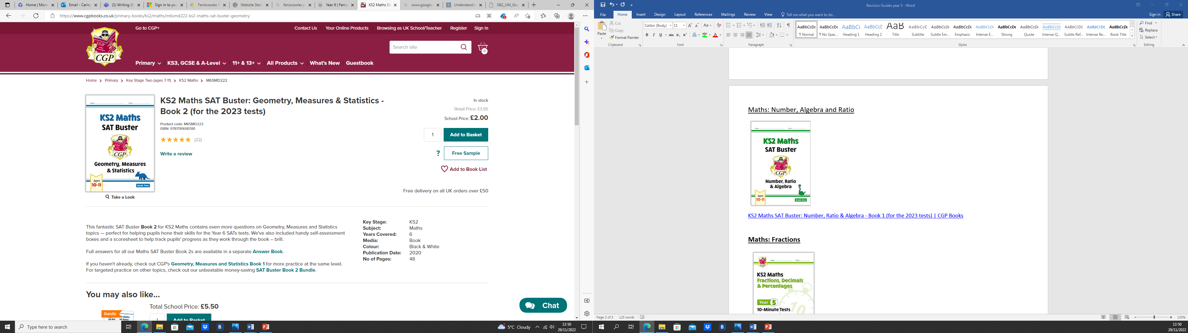

[KS2 Maths SAT Buster: Geometry, Measures & Statistics - Book 2 (for the 2023 tests) | CGP Books](https://www.cgpbooks.co.uk/primary-books/ks2/maths/m6smd222-ks2-maths-sat-buster-geometry)

**Maths: Fractions**

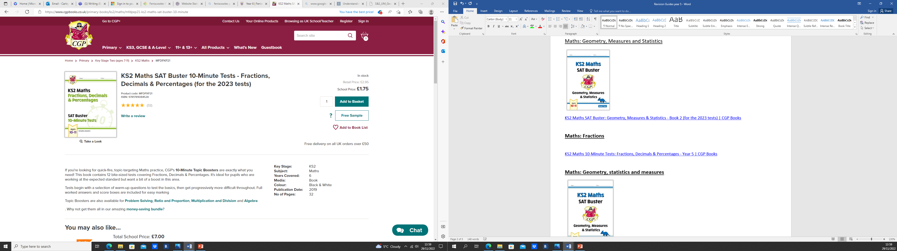

[KS2 Maths SAT Buster 10-Minute Tests - Fractions, Decimals & Percentages (for the 2023 tests) | CGP Books](https://www.cgpbooks.co.uk/primary-books/ks2/maths/mfdpxp21-ks2-maths-sat-buster-10-minute)